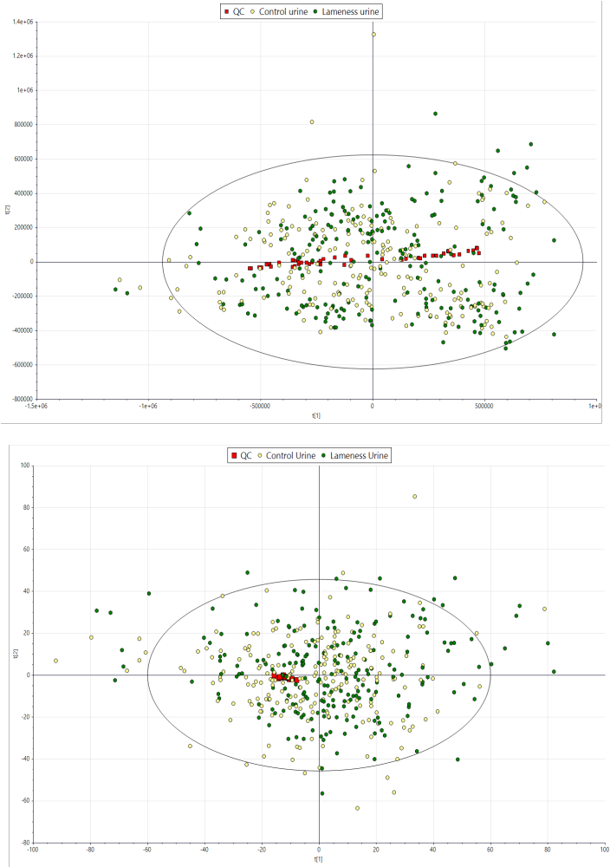
Figure S1 – PCA score plots before (top) and after (bottom) batch correction
using systematic error removal using random forest (SERRF; Fan et al., 2019) of the metabolic profiles of extracted urine samples (n = 424), from cows from 10 commercial dairy herds, and the pooled ABQC sample (n = 47) to assess the LC-HRMS analytical performance and any possible trends (cross-validation top plot: R²X = 0.893, Q² = 0.641; bottom plot: R²X = 0.692; Q² = 0.51).
Figure S2 – PCA score plots before (top) and after (bottom) batch correction
using systematic error removal using random forest (SERRF; Fan et al., 2019) of the metabolic profiles of extracted milk samples (n = 425), from cows from 10 commercial dairy herds, and the pooled ABQC sample (n = 48) to assess the LC-HRMS analytical performance and any possible trends (cross-validation top plot: R²X = 0.868; Q² = 0.817; bottom plot: R²X = 0.739; Q² = 0.576).

Table S1 – Mean predictive performance metrics for all machine‑learning algorithms by farm using urine samples. Values represent mean performance across repeated leave‑one‑farm‑out cross‑validation runs for each algorithm and farm. Performance metrics shown are balanced accuracy, sensitivity, specificity, positive predictive value (PPV), and negative predictive value (NPV). Results are reported for all evaluated algorithms: elastic net (ENET), multivariate adaptive regression splines (MARS), partial least squares (PLS), and random forest (RF).
Farm | Algorithm | Balanced accuracy | Sensitivity | Specificity | PPV | NPV
A | MARS | 0.5611 | 0.6222 | 0.5000 | 0.4857 | 0.6353
A | ENET | 0.4937 | 0.5474 | 0.4401 | 0.4095 | 0.5765
A | PLS | 0.7451 | 0.8235 | 0.6667 | 0.6667 | 0.8235
A | RF | 0.6758 | 0.7629 | 0.5887 | 0.5524 | 0.7882
B | MARS | 0.5657 | 0.5714 | 0.5600 | 0.4211 | 0.7000
B | ENET | 0.4363 | 0.4484 | 0.4242 | 0.6421 | 0.2500
B | PLS | 0.5657 | 0.5714 | 0.5600 | 0.4211 | 0.7000
B | RF | 0.5202 | 0.5003 | 0.5400 | 0.7053 | 0.3300
C | MARS | 0.5260 | 0.5264 | 0.5256 | 0.5200 | 0.5300
C | ENET | 0.5637 | 0.5402 | 0.5872 | 0.7400 | 0.3700
C | PLS | 0.6042 | 0.5833 | 0.6250 | 0.7000 | 0.5000
C | RF | 0.5551 | 0.5538 | 0.5563 | 0.5700 | 0.5400
D | MARS | 0.4276 | 0.4752 | 0.3800 | 0.7909 | 0.1273
D | ENET | 0.5800 | 0.5401 | 0.6200 | 0.8909 | 0.2273
D | PLS | 0.6294 | 0.5588 | 0.7000 | 0.8636 | 0.3182
D | RF | 0.7178 | 0.6240 | 0.8115 | 0.8909 | 0.4636
E | MARS | 0.5258 | 0.5302 | 0.5214 | 0.4400 | 0.6100
E | ENET | 0.5800 | 0.5600 | 0.6000 | 0.7000 | 0.4500
E | PLS | 0.5800 | 0.5600 | 0.6000 | 0.7000 | 0.4500
E | RF | 0.4780 | 0.4846 | 0.4714 | 0.6300 | 0.3300
F | MARS | 0.7344 | 0.8125 | 0.6563 | 0.5417 | 0.8750
F | ENET | 0.6349 | 0.6564 | 0.6134 | 0.5917 | 0.6667
F | PLS | 0.7960 | 0.8824 | 0.7097 | 0.6250 | 0.9167
F | RF | 0.7425 | 0.8320 | 0.6530 | 0.5250 | 0.8917
G | MARS | 0.5955 | 0.5982 | 0.5927 | 0.5810 | 0.6095
G | ENET | 0.6175 | 0.6606 | 0.5743 | 0.4095 | 0.7905
G | PLS | 0.6544 | 0.7500 | 0.5588 | 0.2857 | 0.9048
G | RF | 0.6605 | 0.6952 | 0.6259 | 0.5429 | 0.7619
H | MARS | 0.6565 | 0.7059 | 0.6071 | 0.5217 | 0.7727
H | ENET | 0.6630 | 0.6008 | 0.7253 | 0.8348 | 0.4182
H | PLS | 0.6430 | 0.5938 | 0.6923 | 0.8261 | 0.4091
H | RF | 0.7407 | 0.6756 | 0.8058 | 0.8696 | 0.5636
I | MARS | 0.6278 | 0.5442 | 0.7114 | 0.9000 | 0.2455
I | ENET | 0.4934 | 0.4927 | 0.4942 | 0.7182 | 0.2636
I | PLS | 0.8011 | 0.7600 | 0.8421 | 0.8636 | 0.7273
I | RF | 0.7803 | 0.6485 | 0.9121 | 0.9545 | 0.4818
J | MARS | 0.6092 | 0.6383 | 0.5800 | 0.4636 | 0.7364
J | ENET | 0.5416 | 0.5469 | 0.5363 | 0.4818 | 0.6000
J | PLS | 0.4772 | 0.4762 | 0.4783 | 0.4545 | 0.5000
J | RF | 0.4499 | 0.4497 | 0.4501 | 0.4455 | 0.4545
Table S2 – Mean predictive performance metrics for all machine‑learning algorithms by farm using milk samples. Values represent mean performance across repeated leave‑one‑farm‑out cross‑validation runs for each algorithm and farm. Performance metrics shown are balanced accuracy, sensitivity, specificity, positive predictive value (PPV), and negative predictive value (NPV). Results are reported for all evaluated algorithms: elastic net (ENET), multivariate adaptive regression splines (MARS), partial least squares (PLS), and random forest (RF).
Farm | Algorithm | Balanced accuracy | Sensitivity | Specificity | PPV | NPV
A | MARS | 0.4731 | 0.4937 | 0.4526 | 0.1810 | 0.7889
A | ENET | 0.5005 | 0.5400 | 0.4610 | 0.1429 | 0.8556
A | PLS | 0.4611 | 0.4667 | 0.4556 | 0.0667 | 0.9111
A | RF | 0.6418 | 0.8033 | 0.4803 | 0.1143 | 0.9556
B | MARS | 0.6029 | 0.5414 | 0.6643 | 0.7579 | 0.4000
B | ENET | 0.5187 | 0.4984 | 0.5391 | 0.6105 | 0.4200
B | PLS | 0.5593 | 0.5091 | 0.6095 | 0.7263 | 0.3400
B | RF | 0.4872 | 0.4776 | 0.4968 | 0.7158 | 0.2600
C | MARS | 0.5573 | 0.5391 | 0.5756 | 0.7000 | 0.4000
C | ENET | 0.3748 | 0.4439 | 0.3057 | 0.6900 | 0.1400
C | PLS | 0.5202 | 0.5182 | 0.5222 | 0.6900 | 0.3500
C | RF | 0.5713 | 0.5432 | 0.5993 | 0.7400 | 0.3800
D | MARS | 0.5276 | 0.5285 | 0.5267 | 0.5273 | 0.5273
D | ENET | 0.5338 | 0.5512 | 0.5164 | 0.5273 | 0.5364
D | PLS | 0.6818 | 0.6818 | 0.6818 | 0.6818 | 0.6818
D | RF | 0.5665 | 0.5541 | 0.5788 | 0.6545 | 0.4727
E | MARS | 0.3746 | 0.4310 | 0.3182 | 0.5900 | 0.2100
E | ENET | 0.4749 | 0.4737 | 0.4762 | 0.4500 | 0.5000
E | PLS | 0.4487 | 0.4667 | 0.4308 | 0.5400 | 0.3700
E | RF | 0.4275 | 0.4570 | 0.3980 | 0.6200 | 0.2600
F | MARS | 0.5000 | 0.5000 | 0.5000 | 0.5000 | 0.5000
F | ENET | 0.6977 | 0.6915 | 0.7038 | 0.6833 | 0.6917
F | PLS | 0.6089 | 0.6316 | 0.5862 | 0.5000 | 0.7083
F | RF | 0.6592 | 0.6617 | 0.6567 | 0.6500 | 0.6667
G | MARS | 0.5583 | 0.5833 | 0.5333 | 0.3333 | 0.7619
G | ENET | 0.6167 | 0.6312 | 0.6022 | 0.5524 | 0.6762
G | PLS | 0.6749 | 0.6974 | 0.6525 | 0.6095 | 0.7333
G | RF | 0.6369 | 0.6584 | 0.6154 | 0.5524 | 0.7143
H | MARS | 0.5563 | 0.5694 | 0.5432 | 0.5304 | 0.5818
H | ENET | 0.5752 | 0.6022 | 0.5481 | 0.4609 | 0.6818
H | PLS | 0.5821 | 0.6056 | 0.5587 | 0.5043 | 0.6545
H | RF | 0.5828 | 0.6075 | 0.5581 | 0.5043 | 0.6545
I | MARS | 0.5488 | 0.5913 | 0.5063 | 0.3091 | 0.7273
I | ENET | 0.5955 | 0.5965 | 0.5945 | 0.5909 | 0.6000
I | PLS | 0.6025 | 0.6162 | 0.5888 | 0.5636 | 0.6364
I | RF | 0.6021 | 0.6124 | 0.5918 | 0.5455 | 0.6545
J | MARS | 0.5470 | 0.5385 | 0.5556 | 0.6364 | 0.4545
J | ENET | 0.5326 | 0.5277 | 0.5374 | 0.6091 | 0.4545
J | PLS | 0.5563 | 0.5378 | 0.5748 | 0.7182 | 0.3818
J | RF | 0.5904 | 0.5719 | 0.6089 | 0.6818 | 0.4909

